

MATHEMATICS
YEAR 8

Problem 4 – The Farmer’s Puzzle
Semester 2 2014

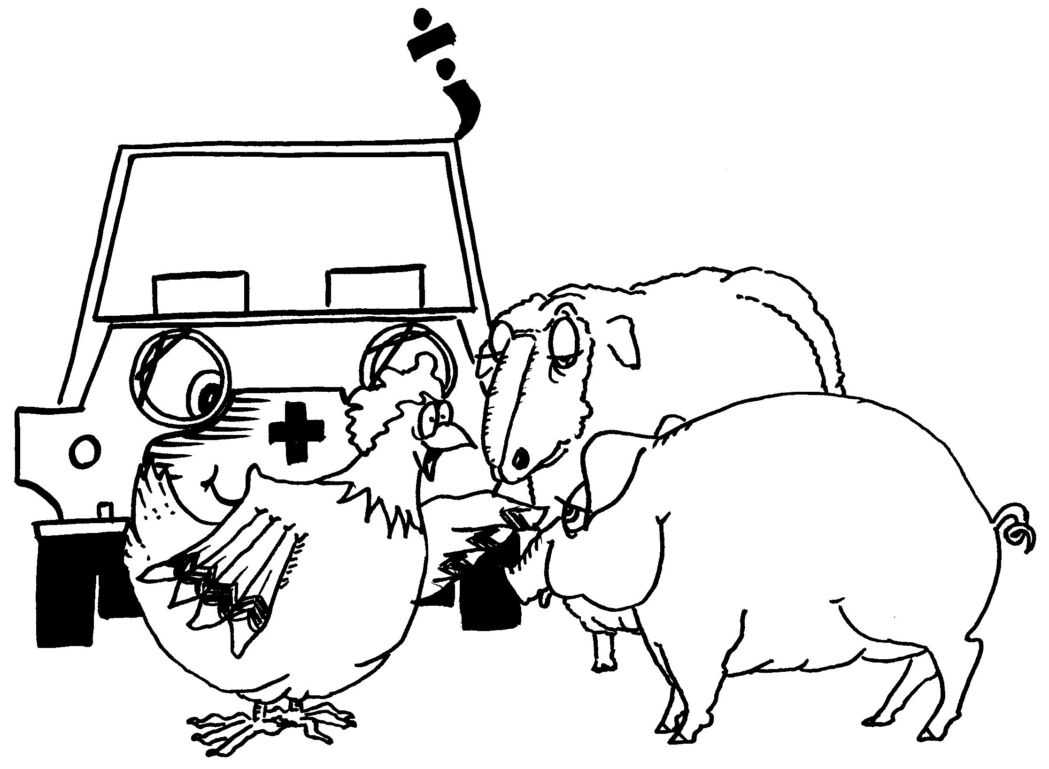

Information for Students

Working time: 30 minutes
Marks available: 12 marks

How to Solve a Problem
READ & UNDERSTAND | Do I understand what the problem is asking? Discuss.
PLAN A STRATEGY | Select a strategy, or strategies, from the Strategy board. Plan how you intend solving the problem.
DO IT | Try out your idea.
CHECK & REFLECT | Did it work out? If so, reflect on the activity.  Perhaps publish your work for others to see.  If not, go back to step one.

STRATEGY BOARD
HAVE I SEEN A SIMILAR PROBLEM?
GUESS & CHECK | LOOK FOR A PATTERN
ACT IT OUT | DRAW A PICTURE OR GRAPH
MAKE A MODEL | MAKE A LIST OR TABLE
TRY ALL POSSIBILITIES | WORK BACKWARDS
SOLVE A SIMPLER  RELATED PROBLEM | USE A SUM OR  NUMBER SENTENCE
SEEK AN EXCEPTION | BREAK IT INTO MORE  MANAGEABLE PARTS

The Farmer's Puzzle
A hundred dollars a farmer paid
For a hundred animals 'through the trade'.
Sheep were ten dollars, pigs were two,
Hens were fifty cents. What did she do?
Used with permission of the publisher ... © Black Douglas Professional Education Services.

Task 1 (4 marks)
- How many hens can the farmer buy for a $100?
Explain why he could not have bought just hens. [2]

- What would she pay for a 100 hens? [1]

- Explain why she cannot buy just pigs or sheep. [1]

Task 2 (6 marks)
One of the strategies you can choose is to make a table and do a guess and check.
- In the table below, why do we start with 96 hens and not 99? [1]

- a. Use the table below or your own strategy (on next page) to solve “The Farmer’s puzzle”. [4]

Hens  $0.50 | Money Remaining | Sheep  $10 | Pigs  $2 | Animals  100 | Money  $100 | Problem Solved  Yes/No
96 | $52 | 1 | 21 | Too many | Yes | No

2. b. My solution [1]
_________ hens, _________ sheep, _________ pigs.

Space for other strategies, if needed.

Extension
So, there is at least one solution.
Are there any more? Demonstrate or Explain. [2]
You may use the back of this page if more space is required.

End of Problem

